Transshipment Modeling

Exploratory Data Analysis

*Table 1: location id, and names for sources, capacity and demand*

**

*Table 2: Average of cost between sources and destination*

*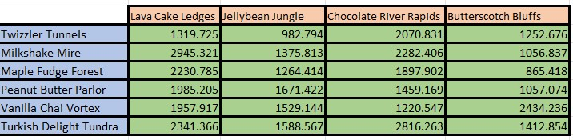*

Model Formulation

1. *Decision Variables  
   Decision variables are the variables in an optimization model whose values are to be determined to achieve the best outcome according to the objective function.*

*In this model = $C$12:$F$17 are Decision Variables*

1. *Objective Function  
   The objective function is a mathematical expression that defines the goal of the optimization model. It is formulated in terms of the decision variables and is either maximized or minimized, depending on the nature of the problem.*

*Objective Function, Total Cost, Minimum =$I$20*

1. *Constraints  
   Constraints are mathematical expressions that represent the limitations or requirements of the optimization problem. They define the feasible region by restricting the values that the decision variables can take.*

*In the model the following Constraints are given:*

**

1. *Total cost average greater than or equal zero*
2. *Capacity should be equal to the given capacity*
3. *Demand less than or equal to the given demand*

Model Optimized for Cost Reduction

**

*Figure 1: Model*

*The model was built to minimize the total average cost between the sources and destination by tracking their IDs from the dataset provided, the demand and capacity was also given in the dataset. After solver optimization the minimum cost is 854752.22.*

Model with Stipulation

*If an additional constraint is added to the model, such that all demand MUST be met. Then the model is not feasible; the output of the solver is given below.*

**

*Based on the outcome of the solver, the constraints cannot be satisfied or met. Meaning with the capacity in hand, the demand of the destination from the sources cannot be fulfilled, implying to out of capacity and demand.*